**Subquery Tasks**

1. Find the **highest-spending customer** in 2024.

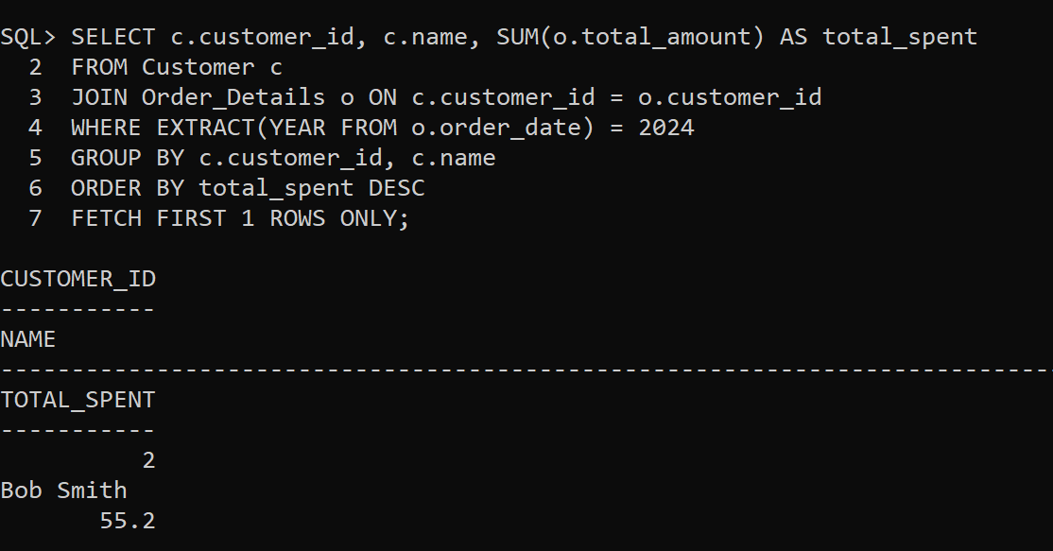

2. Retrieve the **most ordered product** based on quantity.

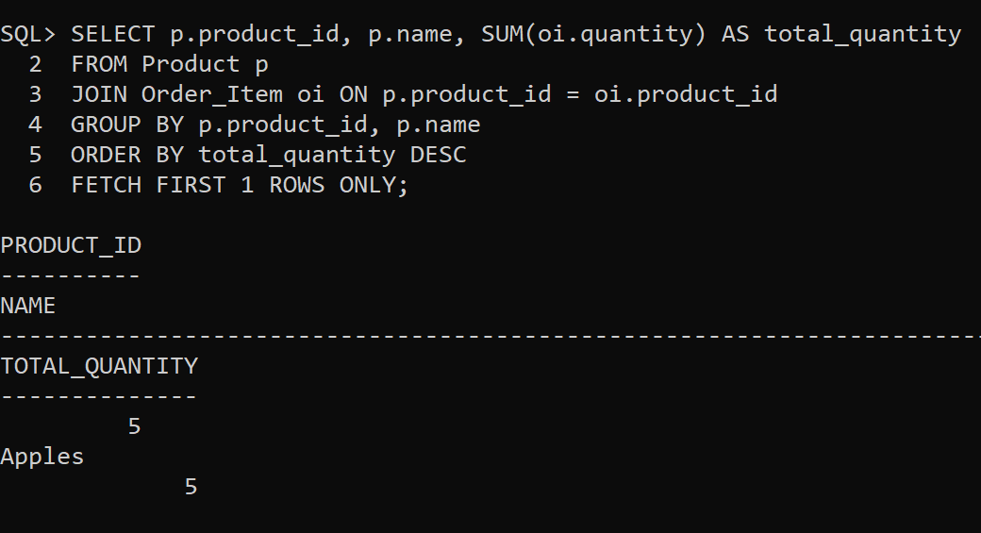

3. Find employees who **earn more than the lowest-paid manager**.

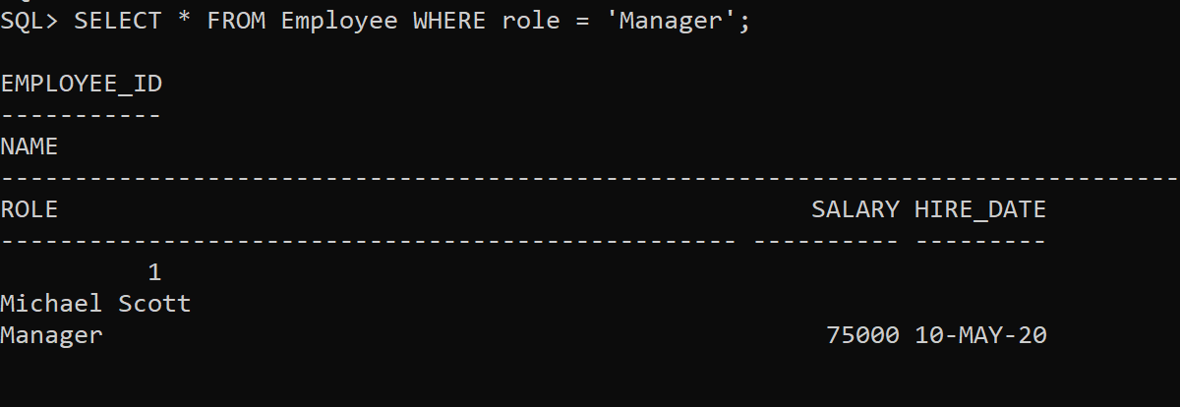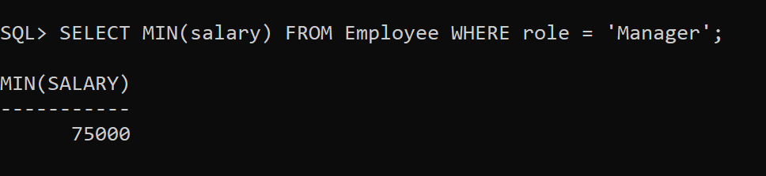

4. Retrieve customers who **placed orders only in 2023 but not in 2024**.

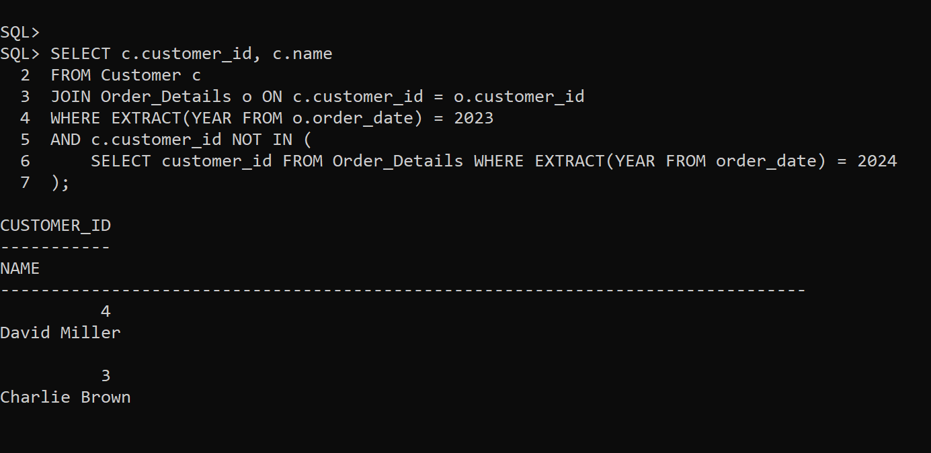

5. Find the **total revenue generated in February 2024**.

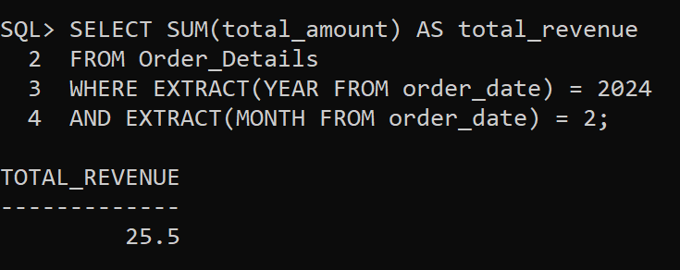

**Joins Tasks**

1. Find the **top 3 customers** with the **highest total spending**.

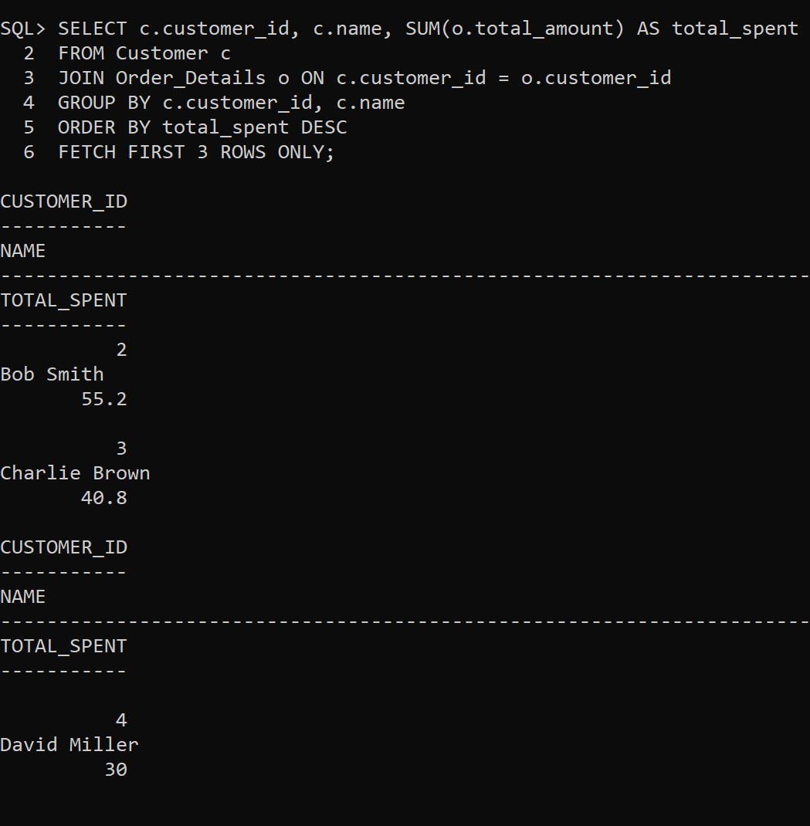

2. Retrieve **employee names** along with the **total revenue generated from their assigned orders**.

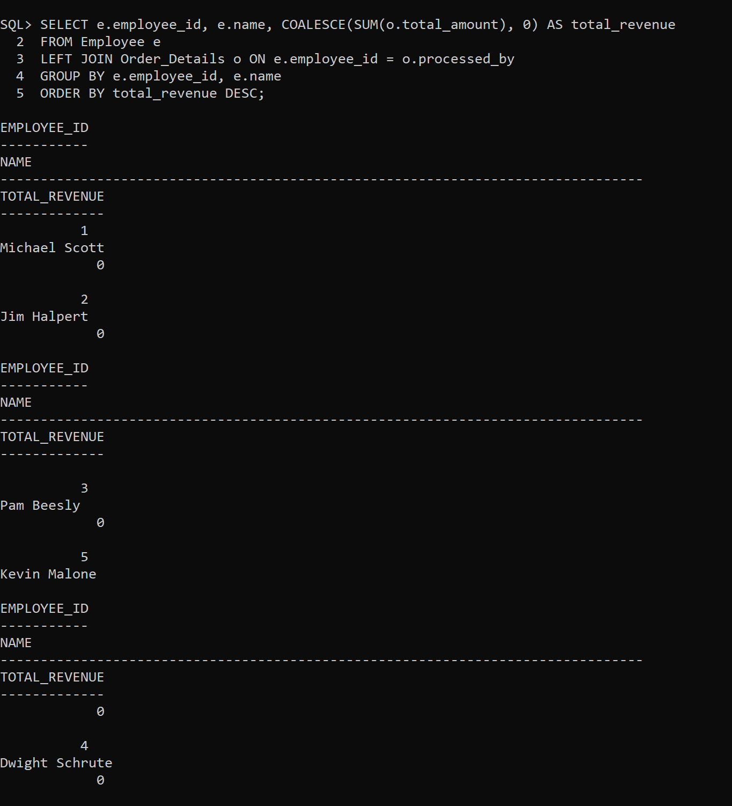

3. Show the **most ordered product category** and its total quantity sold. 4. Retrieve employees who **earn more than their colleagues** using a **SELF JOIN**. 5. Find employees who **work under the same manager** using a **SELF JOIN**.